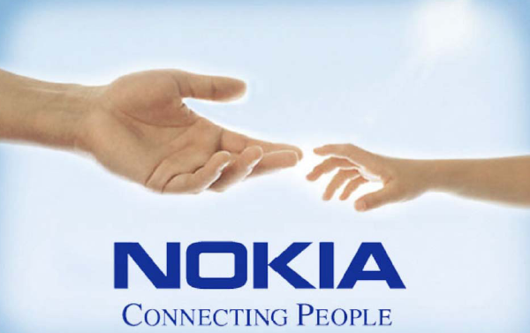

  - Company overview:
Nokia is the world leader in mobile communications, driving the growth and sustainability of the broader mobility industry. Nokia is dedicated to enhancing people's lives and productivity by providing easy-to-us and innovative products like mobile phones, and solutions for imaging, games, media, mobile network operators and businesses.
The roots of Nokia go back to the year 1865 with the establishment of a forest industry enterprise in South-Western Finland by mining engineer Fredrik Idestam. Elsewhere, the year 1898 witnessed the foundation of Finnish Rubber Works Ltd, and in 1912 Finnish Cable Works began operations. Gradually, the ownership of these two companies and Nokia began to shift into hands of just a few owners. Finally in 1967 the three companies were merged to form Nokia Corporation.
At the beginning of the 1980s, Nokia strengthened its position in the telecommunications and consumer electronics markets through the acquisitions of Mobira, Salora, Televa and Luxor of Sweden. In 1987, Nokia acquired the consumer electronics operations and part of the component business of the German Standard Elektrik Lorenz, as well as the French consumer electronics company Oceanic. In 1987, Nokia also purchased the Swiss cable machinery company Maillefer.
In the late 1980s, Nokia became the largest Scandinavian information technology company through the acquisition of Ericsson's data systems division. In 1989, Nokia conducted a significant expansion of its cable industry into Continental Europe by acquiring the Dutch cable company NKF.
Since the beginning of the 1990's, Nokia has concentrated on its core business, telecommunications, by divesting its information technology and basic industry operations.
For more information about how a multi-industry conglomerate became the world leader in mobile communications click : the history of Nokia 1865-2002.

  - Vision
Ten years ago, Nokia had a vision that seemed revolutionary for the times: Voice Goes Mobile! As history shows, this vision became reality in an incredibly short amount of time.
Today, Nokia sees mobility expanding into new areas such as imaging, games, entertainment, media and enterprises. There are new mobile services already taking our industry forward and creating new opportunities. At the same time, major opportunities still exist in bringing mobile voice to completely new users. If it can go mobile – it will!
  - Mission
Connecting people has always been Nokia´s mission. Nokia builds bridges between people – both when they are far apart and face-to-face – and also bridges the gap between people and the information they need.
  - Strategy
Strategy Direction: Nokia intends to capitalize on their leadership role by continuing to enter segments of the mobility industry that they believe will experience rapid growth or grow faster than the industry as a whole. As demand for mobile services increases, they also plan to lead the development and commercialization of high capacity networks. Historically, expanding into segments with these characteristics during the initial stages of their development has helped Nokia to establish itself as one of the world's leading players in mobile communications and has enabled Nokia to significantly influence the ways in which voice and other services have been transferred to a wireless, mobile environment.
As the aim of Nokia continues to do this, their tree main strategies are the following:
Expand mobile voice
Drive consumer multimedia
Bring extended mobility to enterprise:
Nokia believes that their three main strategies will position their business favorably as different digital technologies and industries converge.
Read more

2. Organisation structure:
New Organisational Structure
Effective January 1, 2004, Nokia reorganized its structure in a move to further align the company's overall structure with its strategy. The new structure includes four business groups: Mobile Phones; Multimedia; Networks; and Enterprise Solutions.
The new structure also includes three horizontal groups; Customer and Market Operations; Technology Platforms; and Research, Venturing and Business Infrastructure.
The chart below shows Nokia's new organisational structure.
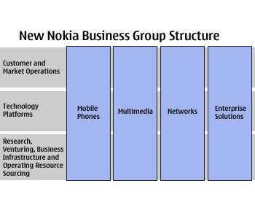

3. Business Environment
The mobile communications industry and the technologies that it exploits are undergoing significant changes.
First, the mobile communications, information technology and media industries are converging into one broader industry, which we call the mobility industry. This is a result of advances in technologies that enable a variety of products and services from different industries to become connected with each other. We expect this convergence to lead to the creation of new mobile devices, new services and new ways in which mobile devices are used.
Second, while participants in the mobile communications industry once provided complete products and solutions, the mobility industry will include increasing numbers of participants who provide specific hardware and software layers for products and solutions. Examples of such layers include operating system and user interface software, chipsets and application software such as games software.
Nokia views this period as one of considerable potential, not just for Nokia but also for the broader mobile communications industry. Mobility has become a major technology and lifestyle influence, transforming the way people conduct their professional lives as well as the way they interact socially.
Read more about Business Environment
4. Nokia in figures:
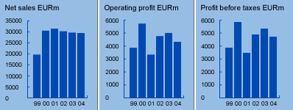
4.1 Key data

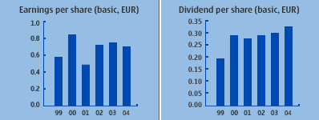
4.2 Share Data

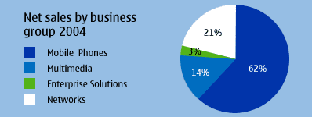
4.3 Business Groups

4.4 Personnel
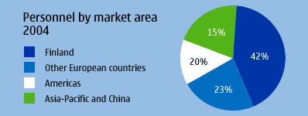

4.5 Markets
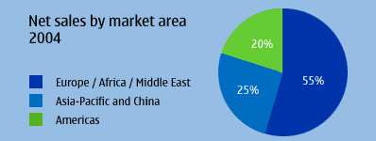

4.6 Financial Statement 2000-2004
